GROUP MEMBERS | Kaushal Pithva  Hamza Vora
SUBMITTED TO | Jhanvi Shukla
ACADEMIC YEAR | 2024 -2027
SUBMISSION DATE | ---------
DIV-ROLL NO. | F31, F48

LJ University
Department of Computer Applications

MediMart: An Online Healthcare Platform.
MASTER OF COMPUTER APPLICATION (INTEGRATED)

INTERNAL GUIDE

TABLE OF CONTENTS
- Introduction
  - Existing System
  - Need for the New System
  - Objective of the New System
  - Problem Definition
  - Core Components
  - Project Profile
  - Assumptions and Constraints
  - Advantages and Limitations

- Project Planning
  - Team Details and Roles
  - Proposed Timeline (Gantt Chart)

- Requirement Determination & Analysis
  - Requirement Determination
  - Targeted Users

- System Design
  - Use Case Diagram
  - Class Diagram
  - Interaction Diagram
  - Activity Diagram
  - Data Dictionary

- Development
  - Development Approach
  - Coding Standards
  - GitHub Repository Details
  - AI Tools/Libraries/APIs Used (if any)
  - Screenshots & Implementation Details

- Proposed Enhancements

- Conclusion

- Bibliography

1. INTRODUCTION
This project documentation serves as a comprehensive system design and development report for "MediMart" a web-based healthcare platform that combines online medicine and health-product discovery, prescription handling, diagnostic test booking, doctor consultation, patient health records, and centralized administration. The document describes the business workflow, system requirements, architecture, database design, UML models, development approach, and implementation plan used to transform healthcare-service requirements into a practical full-stack web application.
The healthcare e-commerce and digital consultation domain increasingly depends on fast access to medicines, diagnostic services, medical experts, and personal health information. The proposed MediMart website follows the functional direction of large digital-health platforms such as Tata 1mg while remaining an independent academic project. The system is intended to give customers one web interface for discovering medicines and health products, uploading prescriptions when required, scheduling diagnostic tests, booking doctor consultations, communicating with a doctor through consultation chat, and viewing health records. Django is used for application logic and secure server-side processing, MySQL is used for relational data storage, and Bootstrap, Tailwind CSS, and JavaScript are used to create a responsive front-end experience.

1.1 Existing System
The existing healthcare purchasing and consultation environment is fragmented across local pharmacies, diagnostic laboratories, hospitals, physician clinics, phone calls, paper prescriptions, and separate digital services. Users often repeat the same patient and address information across different providers and may need separate communication channels for medicine availability, diagnostic appointments, and doctor consultation. In many smaller organizations, stock checking, prescription verification, booking confirmation, and follow-up communication are still handled through spreadsheets, calls, messaging applications, or manual records.
Workflow of the Existing System:
- Product or medicine search: The customer identifies a medicine, wellness product, or diagnostic requirement through a local pharmacy, printed information, telephone inquiry, or a separate website.
- Availability and price confirmation: The customer contacts a provider or checks multiple sources to determine availability, price, dosage or package information, and service details.
- Prescription verification: For prescription-required medicines, the customer provides a paper or digital prescription to the pharmacy for manual validation.
- Lab test booking: The customer selects a diagnostic centre, calls the centre, confirms a test package and appointment slot, and shares patient details and address information.
- Doctor consultation: The customer separately searches for a doctor, contacts the clinic, or books an appointment through another service.
- Record keeping and follow-up: Reports, prescriptions, consultation notes, and order details are stored in different places, making long-term tracking difficult.

1.2 Need for the New System
- Fragmented healthcare workflows require users to switch between pharmacies, laboratories, clinics, and communication channels.
- Manual prescription handling can create delays and make verification status difficult for both customers and operations staff to track.
- Medicine availability, prices, test slots, doctor schedules, and service information may be distributed across various sources instead of one searchable platform.
- Customers may not have a single account view containing orders, prescriptions, lab bookings, consultation history, and health documents.
- Administrators and partner organizations need centralized control over catalog data, inventory, bookings, users, provider verification, and operational records.
- A responsive web platform can reduce repeated data entry, provide consistent workflows, and improve visibility of order and booking status.

1.3 Objective of the New System
The principal objectives of the MediMart platform include:
- Digitalize Healthcare Access: Provide a single portal for medicines, OTC health products, diagnostic tests, doctor consultation, and health-related information.
- Secure User Management: Provide registration, login, password protection, profiles, saved addresses, role-based access, and order history.
- Online Medicine Workflow: Enable product search, category navigation, filtering, product details, cart management, prescription upload, order placement, and order tracking.
- Diagnostic Booking: Allow customers to search and book lab tests or health packages with appointment slot selection and optional home sample collection.
- Doctor Consultation: Allow users to browse doctors, view specializations, book consultations, and use private consultation chat where enabled.
- Health Record Management: Allow users to retain uploaded prescriptions and reports in a structured account area for easier access.
- Centralized Administration: Give administrators control over users, products, inventory, prescriptions, lab tests, doctors, bookings, reports, and operational settings.
- Reliability and Security: Maintain data integrity, secure authentication, server-side validation, and responsive performance using Django and MySQL.

1.4 Problem Definition
The objective of MediMart is to develop a secure, robust, and scalable full-stack web application using Python Django and MySQL. The system brings together medicine and health-product browsing, prescription processing, laboratory test booking, doctor consultation, health-record storage, and administration into a unified platform. The project focuses on reducing fragmented workflows, improving information visibility, simplifying customer interactions, and maintaining structured records through a centralized relational database.

1.5 Core Components
MediMart is structured into seven integrated core functional modules:
Module | Purpose
User Management & Authentication Module | Manages registration, login, logout, password reset, profile management, saved addresses, session management, and role-based authorization for Customer, Doctor, Lab Partner, Pharmacy Partner, and Administrator accounts.
Medicine & Health Product Module | Provides category-based product browsing, medicine search, brand information, product details, pricing, inventory availability, prescription-required flags, images, and related health products.
Prescription Management Module | Allows customers to upload prescriptions, stores file references and verification status, and supports controlled review by authorized pharmacy or administrative staff.
Cart & Order Management Module | Manages cart items, address selection, order creation, order items, order status, amount calculation, and order tracking. The academic scope can use a simulated or configurable checkout workflow without requiring a specific payment gateway.
Lab Test Booking Module | Provides test / package catalog browsing, category filters, appointment slot selection, patient information capture, home sample collection options, booking status, and report linkage.
Doctor Consultation & Chat Module | Provides doctor profiles, specializations, consultation slots, booking status, and private message exchange between customer and doctor for the supported consultation workflow.
Administration & Reporting Module | Provides centralized controls for users, providers, categories, products, inventory, prescriptions, bookings, consultation records, reviews, reports, and operational monitoring.

1.6 Project Profile
Attribute | Details
Project Name | MediMart (A Pharmacy Management Website)
Project Type | Full Stack Website
Development Platform | Django (Python)
Database | MySQL
Team Size | 2 students
Duration | 6 months
Target Users | Customers, Doctors / Health Experts, Lab Partners, Pharmacy Partners, Administrators
Technologies | Django, Python, MySQL, HTML, Bootstrap, Tailwind CSS, JavaScript
Deployment | Localhost / Hosting

1.7 Assumptions and Constraints
Assumptions:
- Users have an active internet connection and a modern web browser.
- Customers provide accurate profile, address, prescription, and appointment information.
- Authorized staff or partner users verify prescription and provider-related information before the final operational action where verification is required.
- The project stores product, test, doctor, booking, and order information in the MySQL database.
Constraints:
- The system is primarily a web-based academic project and depends on network availability for online workflows.
- Actual medicine dispensing, laboratory sample collection, and medical diagnosis are outside the software system boundary.
- External healthcare, logistics, notification, or payment integrations are optional and should only be considered when the required API credentials and agreements are available.
- Health-related information must be managed according to the security and privacy requirements applicable to the deployment environment.

1.8 Advantages and Limitations
Advantages:
- Provides a unified digital access point for medicines, lab tests, doctor consultation, and health records.
- Reduces repeated manual entry and improves tracking of orders, bookings, prescriptions, and consultation activities.
- Provides role-based administration and centralized monitoring for healthcare platform operations.
- Uses Django security mechanisms, server-side validation, and relational constraints to improve application integrity.
- Responsive Bootstrap/Tailwind UI supports desktop and mobile browser access.
Limitations:
- Requires internet connectivity for web-based transactions and consultation communication.
- The software cannot replace professional medical diagnosis or physical laboratory procedures.
- Availability, delivery, appointment fulfillment, and report generation depend on pharmacy, laboratory, and doctor partner operations.
- Advanced real-time communication, notification, payment, and external-provider integrations may require additional APIs or services.

2. PROJECT PLANNING

2.1 Team details and Role
Name of the Student | Role of the Student
Kaushal Pithva | Backend Developer and Database designer
Hamza Vora | Frontend Developer, UI/UX, Tester, Documentation Lead

2.2 Proposed Timeline
The project is planned as a six-month development cycle covering topic approval, requirement analysis, UML / database design, frontend and backend implementation, testing, optimization, documentation, and final presentation.
 | M1 | M2 | M3 | M4 | M5 | M6
Planning
Topic Selection & Approval
Requirement Analysis
System Design
System Design (UML, Database, UI)
Development

Frontend Development
Backend Development
Database Implementation
Testing

Integration & Testing
Bug Fixing & Optimization
Documentation
Documentation
Finalization
Final Review & Presentation

3. REQUIREMENT DETERMINATION & ANALYSIS

3.1 Requirement Determination
Requirements for MediMart were determined by analysing the healthcare services and workflows that the system needs to support. The requirements were organized around stakeholder needs, major functional modules, system expectations, user roles, data requirements, and the overall application workflow.
- Stakeholder-Oriented Analysis: Identify the requirements of customers/patients, administrators, doctors or health experts, laboratory partners, and pharmacy partners.
- Workflow Analysis: Analyse and break down key healthcare workflows such as medicine browsing, prescription submission, medicine ordering, diagnostic test booking, doctor consultation, and health-record management into individual system activities.
- Functional Analysis: Determine the core features required for user registration and authentication, medicine and healthcare-product search, cart and order management, prescription handling, test booking, doctor consultation, health-record management, notifications, and administration.
- Data Analysis: Identify the information that must be stored and managed, including users, medicines, products, prescriptions, orders, laboratory tests, appointments, consultations, messages, payments, and health records.
- UI/UX Analysis: Define simple, responsive, and user-friendly interfaces with clear navigation patterns suitable for both desktop and mobile browser users.
- Security and Non-Functional Analysis: Determine requirements related to authentication, authorization, data privacy, system performance, reliability, scalability, and usability.
Functional Requirements:
- Authentication & Security: User registration, login, logout, password management, session handling, role-based permissions, and secure file handling.
- Medicine & Product Catalog: Product creation, category management, search, filter, details, price, stock quantity, brand, and prescription-required status.
- Prescription Management: Upload, list, verification status, file storage reference, and staff review workflow.
- Cart & Order Management: Add / remove cart items, quantity updates, address selection, order creation, order items, order status, and order history.
- Lab Test Management: Test / package catalog, categories, pricing, sample type, slot selection, booking creation, status updates, and report reference.
- Doctor Consultation: Doctor profiles, specialization, consultation slot, booking, status, and consultation chat/message history.
- Health Records: Store structured or uploaded records such as prescriptions and lab reports against the customer account.
- Reviews & Administration: Product reviews, controlled moderation, dashboard statistics, operational records, and audit-friendly management screens.
Non-Functional Requirements:
- Performance: Target average response time within approximately 2 seconds for common catalog, search, and account requests under normal academic deployment conditions.
- Scalability: Use normalized relational data, indexing, pagination, and efficient Django ORM queries to support concurrent active sessions.
- Security: Use Django authentication, password hashing, CSRF protection, validation, access control, and protected file handling.
- Reliability & Availability: Maintain transactional database operations and scheduled database backups for the deployment environment.
- Usability: Responsive navigation and forms using Bootstrap, Tailwind CSS, and JavaScript with consistent feedback messages.
- Maintainability: Separate Django apps / modules by business responsibility, use meaningful names, reusable templates/components, and version control.

3.2 Targeted Users.
User Type | Role | Responsibilities
Admin | Super Admin | Manage users, categories, products, inventory, prescriptions, doctors, laboratory data, bookings, reviews, reports, and system configuration.
Pharmacy Partner | Operations | Manage assigned product catalog and inventory, review prescription-related orders, and update operational order status.
Lab Partner | Operations | Manage diagnostic tests, available slots, booking status, and report references for completed services.
Doctor / Health Expert | Provider | Maintain professional profile, manage consultation availability, manage bookings, and communicate with customers through consultation chat.
Customer | Primary User | Search medicines/products/tests/doctors, upload prescriptions, manage cart, place orders, book lab tests, book consultations, use chat, view records and history.

4. SYSTEM DESIGN

4.1 Use Case Diagram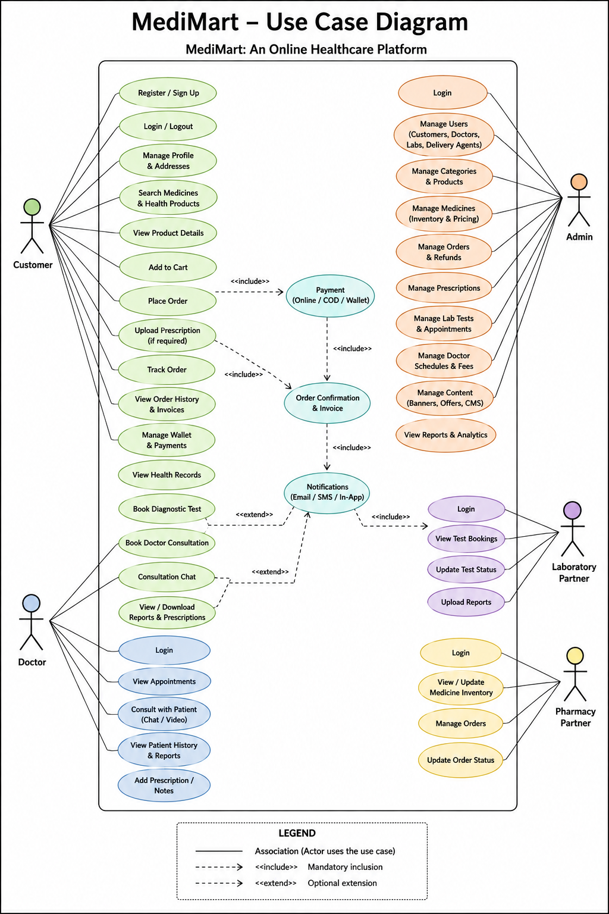

4.2 Class Diagram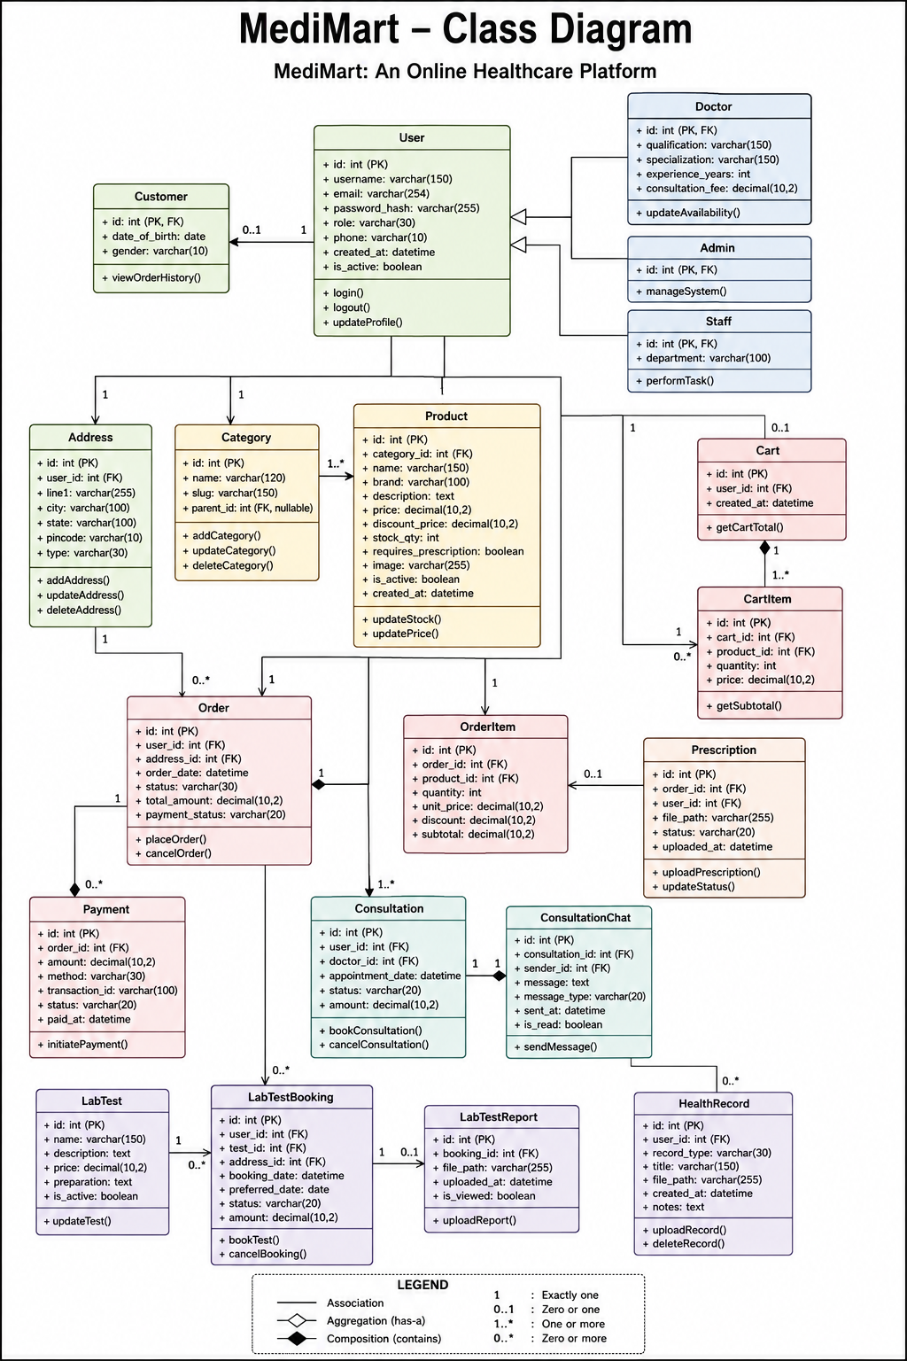4.3 Interaction Diagram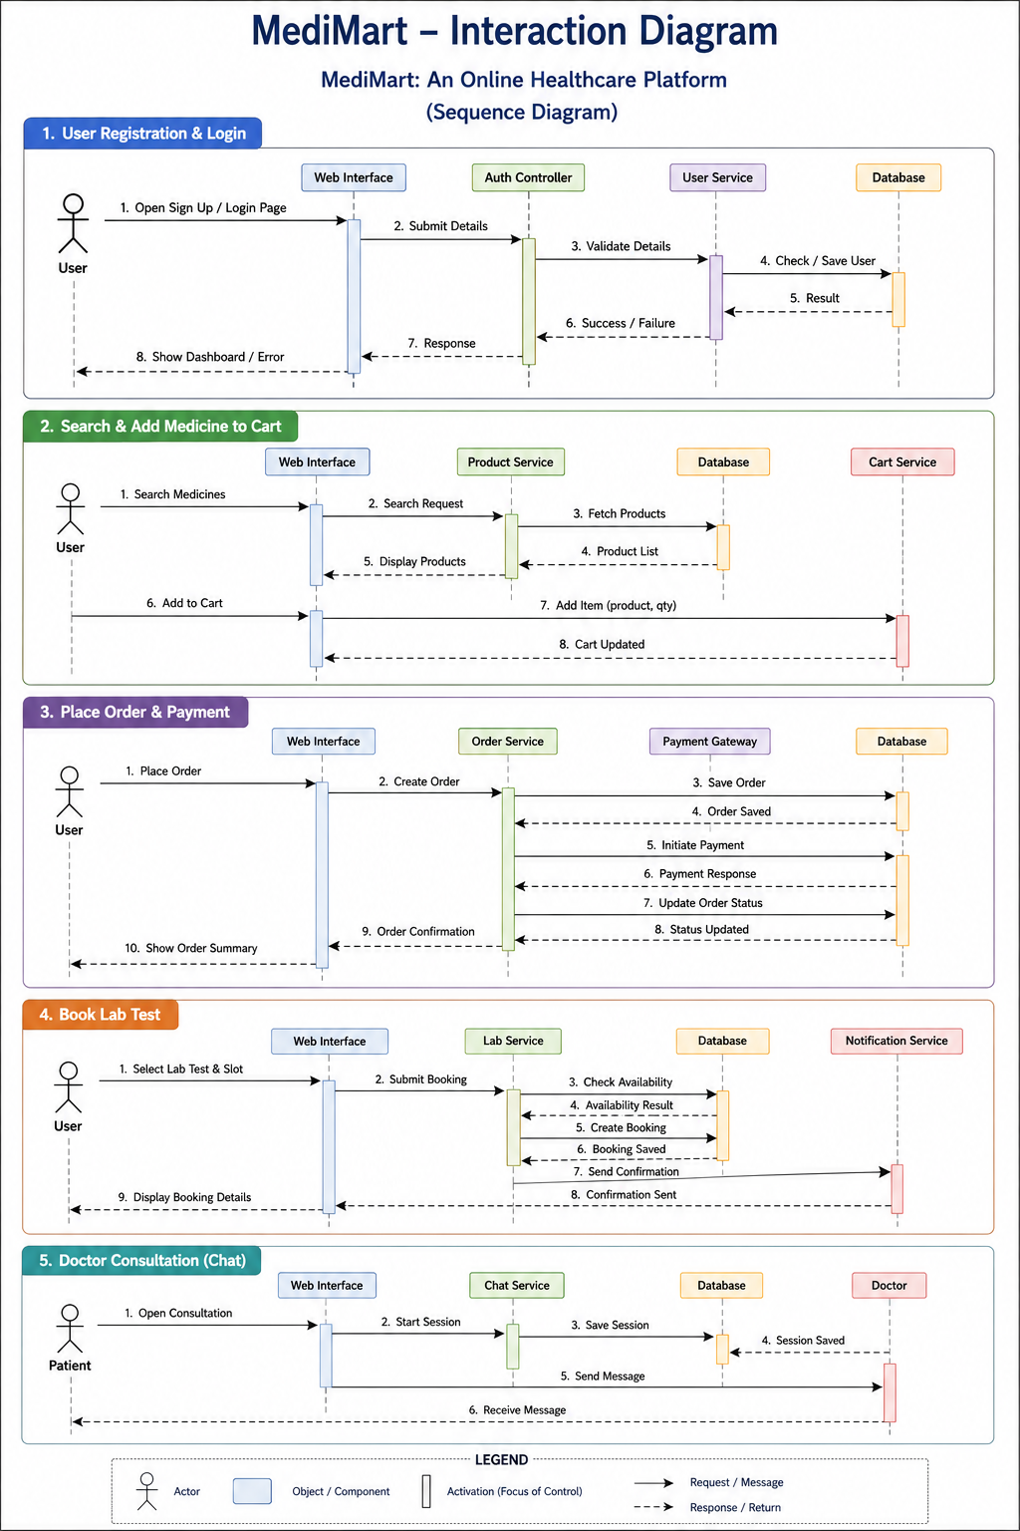4.4 Activity Diagram

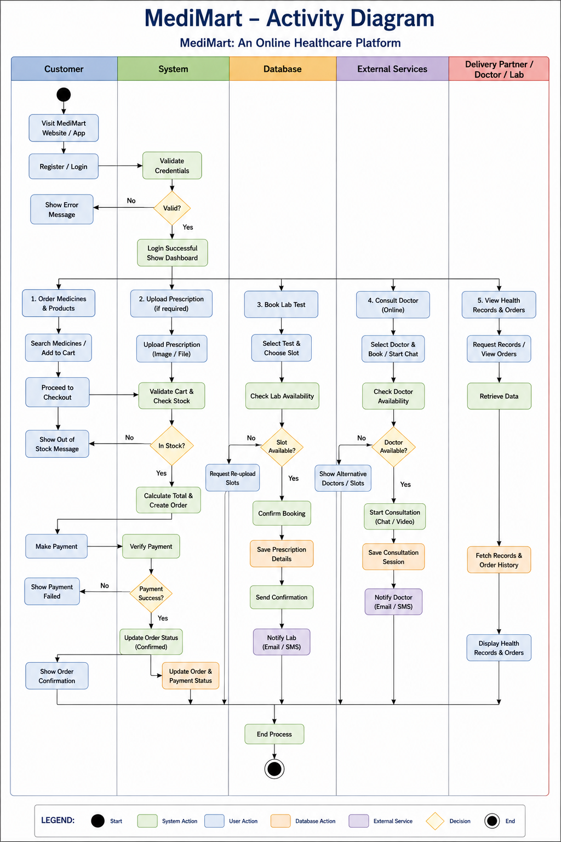

4.5 Data Dictionary

Table: Users
Column Name | Data Type | Key / Size | Description | Example
id | INT | PK | Unique user identifier | 101
username | VARCHAR (150) | Unique | Login or display identifier | kaushal24
email | VARCHAR (254) | Unique | Email address | user@example.com
password_hash | VARCHAR (255) | - | Hashed password value | $2y$10$XelWzsYp
role | VARCHAR (30) | - | Customer / Admin / Doctor /  Lab / Pharmacy | Customer
phone | VARCHAR (10) | - | Contact number | 1234567890
created_at | DATETIME | - | Account creation timestamp | 2026-07-01 10:00
is_active | BOOLEAN | - | Account activation state | True

Table: Addresses
Column Name | Data Type | Key / Size | Description | Example
id | INT | PK | Address identifier | 201
user_id | INT | FK | References users.id | 101
line1 | VARCHAR (255) | - | Address line | 12 Main Road
city | VARCHAR (100) | - | City | Ahmedabad
state | VARCHAR (100) | - | State / region | Gujarat
pincode | VARCHAR (10) | - | Postal code | 380001
type | VARCHAR (30) | - | Home / Work / Other | Home
Table: Categories
Column Name | Data Type | Key / Size | Description | Example
id | INT | PK | Category identifier | 10
name | VARCHAR (120) | - | Medicine or health-product category | Diabetes Care
slug | VARCHAR (150) | Unique | URL-friendly category identifier | diabetes-care
parent_id | INT | FK nullable | Optional parent category | 1

Table: Products
Column Name | Data Type | Key / Size | Description | Example
id | INT | PK | Product identifier | 5001
category_id | INT | FK | Product category | 10
name | VARCHAR (255) | - | Medicine or health product name | Example Tablet 500mg
brand | VARCHAR (120) | - | Brand name | Example Pharma
mrp | DECIMAL (10,2) | - | Maximum retail or listed price | 120.00
price | DECIMAL (10,2) | - | Selling price used by application | 99.00
stock_qty | INT | - | Available inventory quantity | 250
rx_required | BOOLEAN | - | Whether prescription verification is required | False
description | TEXT | - | Product description and usage information | Product details

Table: Cart
Column Name | Data Type | Key / Size | Description | Example
id | INT | PK | Cart identifier | 8001
user_id | INT | FK | Cart owner | 101
created_at | DATETIME | - | Cart creation time | 2026-07-02 09:00
updated_at | DATETIME | - | Last cart update | 2026-07-02 09:15

Table: CartItems
Column Name | Data Type | Key / Size | Description | Example
id | INT | PK | Cart item identifier | 8002
cart_id | INT | FK | Cart reference | 8001
product_id | INT | FK | Product reference | 5001
qty | INT | - | Requested quantity | 2
unit_price | DECIMAL (10,2) | - | Price at cart entry | 99.00

Table: Orders
Column Name | Data Type | Key / Size | Description | Example
id | INT | PK | Order identifier | 9001
user_id | INT | FK | Customer reference | 101
address_id | INT | FK | Delivery address | 201
status | VARCHAR (30) | - | Pending / Confirmed /  Dispatched / Delivered / Cancelled | Confirmed
total_amount | DECIMAL (10,2) | - | Order total amount | 198.00
created_at | DATETIME | - | Order creation timestamp | 2026-07-02 09:20

Table: OrderItems
Column Name | Data Type | Key / Size | Description | Example
id | INT | PK | Order item identifier | 9101
order_id | INT | FK | Order reference | 9001
product_id | INT | FK | Product reference | 5001
qty | INT | - | Ordered quantity | 2
unit_price | DECIMAL (10,2) | - | Price captured for order item | 99.00

Table: Prescriptions
Column Name | Data Type | Key / Size | Description | Example
id | INT | PK | Prescription identifier | 7001
user_id | INT | FK | Uploader / customer | 101
file_path | VARCHAR (500) | - | Stored file reference | media/prescriptions/p1.pdf
status | VARCHAR (30) | - | Pending / Verified /  Rejected | Pending
verified_by | INT | FK nullable | Admin / pharmacy reviewer | 501
uploaded_at | DATETIME | - | Upload timestamp | 2026-07-02 09:10

Table: LabTests
Column Name | Data Type | Key / Size | Description | Example
id | INT | PK | Diagnostic test identifier | 3001
name | VARCHAR (255) | - | Test or health package name | Complete Blood Count
category | VARCHAR (120) | - | Test category | Blood Test
price | DECIMAL (10,2) | - | Listed test price | 450.00
sample_type | VARCHAR (80) | - | Sample required | Blood
report_eta | VARCHAR (80) | - | Expected report timing | 24 hours

Table: LabBookings
Column Name | Data Type | Key / Size | Description | Example
id | INT | PK | Booking identifier | 3101
user_id | INT | FK | Customer reference | 101
lab_test_id | INT | FK | Booked test | 3001
slot | DATETIME | - | Appointment / collection slot | 2026-07-03 08:30
address_id | INT | FK | Collection address | 201
status | VARCHAR (30) | - | Pending / Confirmed /  Completed / Cancelled | Confirmed
report_path | VARCHAR (500) | - | Report file reference when  available | media/reports/r1.pdf

Table: Doctors
Column Name | Data Type | Key / Size | Description | Example
id | INT | PK | Doctor identifier | 4001
user_id | INT | FK | Linked user account | 501
speciality | VARCHAR (120) | - | Medical specialty | General Physician
license_no | VARCHAR (100) | - | Professional license reference | LIC-001
fee | DECIMAL (10,2) | - | Consultation fee | 499.00
verified | BOOLEAN | - | Verification state | True

Table: Consultations
Column Name | Data Type | Key / Size | Description | Example
id | INT | PK | Consultation identifier | 4101
user_id | INT | FK | Patient/customer | 101
doctor_id | INT | FK | Doctor reference | 4001
mode | VARCHAR (30) | - | Chat/Video/Audio if implemented | Chat
slot | DATETIME | - | Consultation slot | 2026-07-03 17:00
status | VARCHAR (30) | - | Pending / Confirmed /  Completed / Cancelled | Confirmed

Table: Messages
Column Name | Data Type | Key / Size | Description | Example
id | INT | PK | Message identifier | 4201
consultation_id | INT | FK | Consultation reference | 4101
sender_id | INT | FK | User who sent message | 501
body | TEXT | - | Message content | Please share your report
sent_at | DATETIME | - | Message timestamp | 2026-07-03 17:05

Table: HealthRecords
Column Name | Data Type | Key / Size | Description | Example
id | INT | PK | Health record identifier | 6001
user_id | INT | FK | Patient reference | 101
record_type | VARCHAR (80) | - | Lab Report/Prescription/etc. | Lab Report
file_path | VARCHAR (500) | - | Stored document reference | media/reports/cbc.pdf
record_date | DATE | - | Date associated with record | 2026-07-03

Table: Reviews
Column Name | Data Type | Key / Size | Description | Example
id | INT | PK | Review identifier | 10001
user_id | INT | FK | Reviewer/customer | 101
product_id | INT | FK | Reviewed product | 5001
rating | INT | 1-5 | Customer rating | 5
comment | TEXT | - | Optional review comment | Good experience

5. DEVELOPMENT

Development Approach
MediMart follows an Agile-oriented development approach in which the system is divided into manageable modules and implemented incrementally. Frontend, backend, database, and testing activities are performed in parallel with regular integration checkpoints.
- The project is organized into functional milestones such as requirements, UML / database design, authentication, catalog, cart / order, prescription, lab booking, consultation, administration, and testing.
- Django models and migrations are used to define and evolve the MySQL schema.
- Django views, forms, templates, URL routing, and application services are used to implement business workflows.
- Bootstrap and Tailwind CSS are used for responsive layout and reusable UI components, while JavaScript supports dynamic interactions, validation feedback, filters, and AJAX - style enhancements where implemented.
- Git is used for source-code version control, and testing is performed during development rather than only at the end.

Coding Standards
Naming Conventions:
- Python Classes / Models: PascalCase (e.g., ProductView, LabBookingService)
- Python Functions / Variables: snake_case (e.g., create_order(), verify_prescription())
- Variables: snake_case, e.g., user_profile, order_total
- Constants: UPPER_CASE (e.g., UPPER_SNAKE_CASE, e.g., MAX_UPLOAD_SIZE)
- HTML / CSS / JS: for CSS: camelCase, for JS variables (e.g., itemQuantity).
Code Style Guidelines:
- Meaningful and descriptive names are used for variables, functions, classes, database fields, and other programming elements to improve code readability and maintainability.
- Functions are kept concise and focused on a single responsibility, ensuring that each function performs one specific task and avoids unnecessary complexity.
- Consistent indentation of four spaces is maintained throughout the source code to ensure proper formatting and readability, especially in Python and Django files.
- Comments are added wherever complex logic, important business rules, validation processes, or database operations require additional explanation.
- A clear Separation of Concerns is maintained by keeping presentation, business logic, and data management separate. HTML templates are primarily used for displaying content and do not contain complex business logic.
- Code duplication is minimized by following the DRY (Don't Repeat Yourself) principle. Common functionality is implemented through reusable functions, classes, templates, and components.
- Database tables and Django model classes follow consistent and meaningful naming conventions. Django model classes use PascalCase, such as User, Product, Order, and LabBooking, while database fields use clear and descriptive names.

5.3 GitHub Repository Details
Source code was managed using Git version control hosted on GitHub:
- Repository Name: MediMart
- Branch Structure: 'main' branch for stable production releases; 'test-env' branch for feature integration; dedicated feature branches for module development.
- Collaboration Policy: Mandatory Pull Request reviews before merging code into the 'test-env' branch.

5.4 AI tools/ Libraries/API used (If Any) (Incomplete, will be decided later)
This section should list the Artificial Intelligence tools, libraries, frameworks, or APIs used in the project, if applicable. For each tool, mention its name, purpose, version (if relevant), and explain how it contributes to the project's functionality, such as automation, prediction, chatbot development, image processing, recommendation systems, or data analysis.
Examples:
- AI Tool: ChatGPT – Used for generating content, code suggestions, or documentation.
- Library: TensorFlow / Scikit-learn – Used for machine learning model development.
- API: OpenAI API / Google Vision API – Used to integrate AI capabilities into the application.

5.5 Screenshots & Implementation Details (Incomplete, will be decided later)
Definition:
Include screenshots of key screens/modules and explain implementation details.
[SCREENSHOT 1: LOGIN SCREEN]
Description: The entry portal allows multi-role authentication for buyers, sellers, and system administrators, complete with security controls.
Implementation Details: Built using Django's built-in Authentication views with CSRF tokens. Form fields enforce client-side validation alongside SHA-256 backend password hashing.
Implementation Details:
- Username field with validation (minimum 5 characters)
- Password field with encryption using SHA-256
- Remember Me checkbox for session management
- Forgot Password link for password recovery

[SCREENSHOT 2: DASHBOARD SCREEN]
Description: Control center for manufacturers to oversee stock inventory levels, evaluate pending RFQs, and monitor sales metrics.
Implementation Details: Uses Django ORM database aggregations to compute live order metrics. Features dynamic low-stock alerts and action buttons for rapid quote responses.
Implementation Details:
- Displays key performance indicators
- Shows recent transactions
- Provides quick access to major functions
- Implement role-based access control

[SCREENSHOT 3: MAIN MODULE SCREEN]
Description: Product showcase interface displaying tiered quantity pricing and direct RFQ modal triggers.
Implementation Details: Employs JavaScript for dynamic price calculations based on volume inputs. RFQ forms submit asynchronously via AJAX to ensure a seamless user experience.
Implementation Details:
- Form validation for all fields
- Search and filter functionality
- Database transactions for data integrity
- Real-time data processing

6. PROPOSED ENHANCEMENTS
The following enhancements can be considered for future versions of the MediMart platform to improve its functionality, security, accessibility, and overall healthcare-service experience:
- Mobile Application Development.
Develop dedicated Android and iOS applications using Flutter to provide users with convenient access to medicines, health products, lab test bookings, doctor consultations, prescriptions, orders, and health records through mobile devices.
- Integrated Online Payment Gateway.
Integrate secure online payment services such as Razorpay or Stripe to support digital payments for medicine orders, diagnostic tests, and doctor consultations. This can provide users with faster and more convenient checkout options.
- AI-Based Health Recommendations.
Introduce AI-based recommendation features to analyze user searches, purchase history, and healthcare preferences and provide relevant health products, diagnostic packages, or general health-related recommendations. Such features would be designed as assistance and would not replace professional medical advice.
- Real-Time Notifications and Communication.
Implement real-time notifications through email, SMS, or push notifications for order updates, prescription verification, lab appointment reminders, consultation schedules, report availability, and other important account activities.
- Advanced Security and Privacy Features.
Strengthen the protection of sensitive healthcare information by introducing enhanced authentication, secure file storage, improved access controls, activity monitoring, regular security audits, and additional privacy mechanisms for prescriptions, reports, and consultation records.
- Performance and System Scalability.
Improve system performance and scalability through database optimization, caching, efficient queries, indexing, pagination, optimized file handling, and improved server configuration. These enhancements will help MediMart support a larger number of users, products, bookings, and healthcare records efficiently.

7. CONCLUSION
MediMart is a web-based healthcare platform that combines medicines, health products, prescription management, diagnostic test booking, doctor consultation, and health-record management in one system. It makes healthcare services more organized, convenient, and accessible for users.
The platform supports user registration, product search, cart management, prescription upload, medicine ordering, order tracking, lab-test booking, doctor consultation, and health-record viewing. It also provides separate functions for administrators, pharmacies, laboratories, and doctors.
MediMart is developed using Python Django, MySQL, HTML, Bootstrap, Tailwind CSS, and JavaScript. Django manages the application and database operations, while MySQL stores important information such as users, products, orders, prescriptions, bookings, consultations, and health records.
The project follows an Agile development approach that includes planning, design, development, testing, and documentation. Security, usability, performance, and data accuracy are also considered during development.
MediMart is an academic project and does not replace professional medical advice, laboratory services, or medicine dispensing. Future improvements may include mobile applications, online payments, AI-based recommendations, real-time notifications, and stronger security.
Overall, MediMart provides a useful foundation for a centralized digital healthcare platform that brings several healthcare services together in one application.

8. BIBLIOGRAPHY
The following official documentation and online technical resources were referred to during the analysis, design, development, and documentation of the MediMart project:
- Django Software Foundation. https://docs.djangoproject.com/
- Python Software Foundation. https://docs.python.org/
- Oracle Corporation. https://dev.mysql.com/doc/refman/8.4/en/
- Bootstrap Team. https://getbootstrap.com/docs/
- Tailwind Labs. https://tailwindcss.com/docs
- GitHub, Inc. https://docs.github.com/
- Django Software Foundation. https://docs.djangoproject.com/en/6.1/topics/security/

